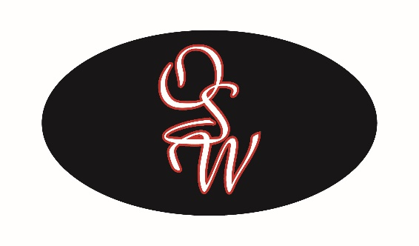

Job Description: Human Resources Administrator

OSW Equipment & Repair, LLC, a subsidiary of Federal Signal Corporation, is the largest truck body and trailer manufacturer in the Pacific Northwest. OSW’s main facility is located in the Maltby area in Snohomish County. OSW and has been in business for over 20 years and has branches in Edmonton, Canada and Tempe, Arizona.

We are looking to add a Human Resources Administrator to our growing team. The HR Administrator will provide a wide range of support to our employees for our U.S. locations as well as support the HR Manager. We are willing to train the right candidate. If you are bright, highly motivated, and a team player we encourage you to apply!

Job Summary: Responsible for meeting customer needs by:
- Assisting with the recruitment activities aimed at efficient and accurate hiring of qualified candidates (includes advertising/postings, interviewing, reference checking, coordinating interviews with management, tracking, etc.)
- Compiling and updating employee records, files, and documents
- Conducting, educating, and ensuring completion of employee orientation and benefit administration
- Create policies, processes, and documents.
- Assisting with employees’ needs.
- Assist with payroll processing duties, bi-weekly (data entry).
- Creating and maintaining a welcoming environment for employees and upholding the highest level of moral and ethical decisions in everything that we do.
- Assisting to maintain a productive partnership with supervisors and employees to build trust.
- Assist with Safety data collection, minutes for meetings, and safety files.
- Assisting projects that align with the human resources and organization goals.
- Communication Distribution.
- Other duties as assigned.

Job Requirements:

- Previous related experience of 1-2 years preferred.
- Good interpersonal skills to deal effectively with a wide variety of people promoting a positive company image.
- Uphold the highest level of morals, ethics, and honesty.
- Maintain the highest level of confidentiality.
- Knowledge of Microsoft Office Suite and Teams preferred.
- Knowledge of UlitPro HRIS/Payroll system preferred.
- Excellent communication skills, follow-through and problem solving.

Wage Expectations:

$20.00 - $25.00 per hour

________________________________ ___________________________________ ___________
Print Signature Date

