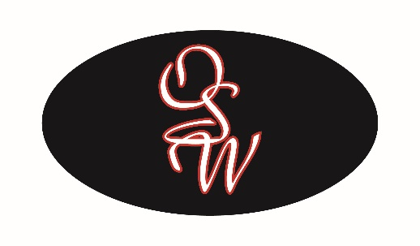

Inside Sales Manager

OSW Equipment & Repair, LLC COMPANY DESCRIPTION

OSW Equipment, the largest truck body and trailer manufacturer in the Pacific Northwest. OSW has been in business for over 20 years, and the company is positioning to experience significant growth.

Please visit https://oswequipment.com for more information.

JOB SUMMARY
Experienced Analyst and systems project manager will report to Director of Sales. This is position is responsible for sales, costs and business analytics and project support, including new product launches, marketing materials generation and management and other IT related business process support.
Essential Duties and Responsibilities:
- Analyze sales, costs and revenue data and hold regular review meetings with management for pricing recommendations ensuring best market pricing is achieved/maintained.
- Develop and track project plans, tollgates and task tracking to monitor success of small and medium internal projects.
- Provide data supporting changes before and after project changes to ensure effectivity of changes / updates made.
- Coordinate and execute projects in conjunction with other TBEI companies and supporting organizations.
- Web Development and marketing materials development and assistance.
- Lead, train, develop and manage inside sales coordinators ensuring order entry, production order processing and production planning communications with operations are effective and timely.
- Create clear goals and expectations for the team and ensure standard work, goals and daily tactical targets are exceeded.

Qualifications and Skills
- 5+ years of experience in Inside sales, production planning, data analytics, data mining, project management or any combination thereof preferred.
- Experience in project management or process improvement / Lean six sigma and data supported process improvement.
- Web Development and Marketing materials development experience desired.
- Strong Excel, PowerBI, SQL skills/ experience desired.
- Strong attention to detail, leadership and team building skills.
POSITION REPORTS TO: Director Sales
Management reserves the right to change duties and responsibilities set forth herein at any time. This position outlines the basic tasks and requirements for the position noted. It is not comprehensive of all the job duties for the employee. In addition to the above each employee may be required to cross train for position(s) within the company from time to time.
Non-Exempt Position
Compensation Package, DOQ / DOE
· Competitive Salary - DOE
· Medical Benefits
· Company Paid Life Insurance
· Voluntary Life Insurance Benefits
· 401k with Company Match
· Paid PTO
OSW Equipment & Repair, LLC provides equal employment opportunities (EEO) to all employees and applicants for employment without regard to race, color, religion, sex, national origin, age, disability, or genetics. In addition to federal law requirements, OSW Equipment & Repairs, LLC complies with applicable state and local laws governing nondiscrimination in employment in every location in which the company has facilities. This policy applies to all terms and conditions of employment, including recruiting, hiring, placement, promotion, termination, layoff, recall, transfers, leaves of absence, compensation and training.
OSW Equipment & Repair, LLC expressly prohibits any form of workplace harassment based on race, color, religion, gender, sexual orientation, gender identity or expression, national origin, age, genetic information, disability, or veteran status. Improper interference with the ability of OSW employees to perform their job duties may result in discipline up to and including discharge.

Name of Employee

Signature_________________________________

Date_____________________________________

OSW Equipment & Repair, LLC

Signature__________________________________

Date______________________________________

